Algebra 2/Trig H

Collection of problems as practice for the final

Test Format:

- The test has about 30 questions. Some with multiple parts.
- You have 120 minutes to complete the test (more if you have accommodations).

Common test instructions:
- You should SHOW YOUR WORK for all parts of the answer to receive full credit.
- Write your answers using either blue or black ink or a pencil. Please don't use red pen.
- There is a clearly indicated space to write down your answer for each question. CLEARLY write your final answer in the space provided. Only ONE answer per question will be considered.

Calculator is NOT allowed on the test.
With accommodation, you are allowed a 4-operations calculator.

Practice questions:

Will be handed out two weeks before the test.

Material covered:

All the material we covered this year. First and second semester included.
The material is available on schoology and on www.drbaharav.org.

==== End

- Simplify:  $$\left(2x-3\right)⋅\left({4x}^{2}+6x+9\right)-(4x^{2}-3)$$  Result:______________________________ | - Simplify:  $$\left(2x-3\right)⋅\left(2x+3\right)-(x+4)(2x-8)$$  Result:______________________________
- Find the equation of the line perpendicular to the line  $$y=5-2x$$  and that includes the point $\left(1,0\right)$.  What is the intersection point of these two lines?  Line equation:______________________________  Intersection point: _________________________  Plot: | - Find the equation of the line parallel to the line  $$y-2x=5$$  and that includes the point $\left(1,1\right)$.  What is the intersection point of these two lines?  Line equation:______________________________  Intersection point: _________________________  Plot:
- Factor completely:  $$8x^{3}+27$$  Answer:______________________________ | - Factor completely:  $$x^{2}-8x+15$$  Answer:______________________________

- Factor completely:  $$18x^{3}-8x$$  Answer:______________________________ | - Factor completely:  $$6x^{2}-19x+15$$  Answer:______________________________
- Simplify and give restricted values:  $$\frac{x^{2}-4}{x-3}⋅\frac{x^{2}-9}{x^{2}+5x+6}$$  Restricted Values:_ ________________________  Simplified:______________________________ | - Simplify :  $$\frac{(x^{3}-y^{3})}{2}÷ \frac{2x^{3}y-2{xy}^{3}}{x+y}$$  Restricted Values:_ ________________________  Simplified:______________________________

- Simplify and give restricted values:  $$\frac{1}{x-4}-\frac{x-1}{x+4}-\frac{6x-16}{x^{2}-16}$$  Restricted Values:_ ________________________  Simplified:______________________________ | - Simplify:  $$\frac{1}{x-4}-\frac{x-1}{x^{2}-x-12}$$  Restricted Values:_ ________________________  Simplified:______________________________
- Solve:  $$\frac{2}{x^{2}-9}-\frac{2}{x+3}=\frac{x-4}{x-3}$$  Solution: x= ____________________________ | - Solve:  $$\frac{2}{x^{2}-3x-4}=\frac{1}{x^{2}-5x+4}$$  Solution: x= ____________________________
- Solve:
$$\frac{7}{5x-1}= \frac{1}{(x+1)}$$

Solution: x= ____________________________

- Divide using synthetic division:
$$(x^{5}+5x^{4}-x^{3}-3x^{2}+5x-25)÷(x+5)$$

Answer: ____________________________

- Divide  $$\frac{30x^{8}-15x^{6}+40x^{4}}{5x^{4}}$$  Answer: ____________________________ | - Divide:  $$\frac{\left(\frac{1}{x-4} - \frac{1}{x+4}\right)}{\left(\frac{1}{x-4} + \frac{1}{x+4}\right)}$$  Answer: ____________________________
- Divide using synthetic division:  $$(x^{5}-32)÷(x-2)$$  Answer: ____________________________ | - Divide (long division) :  $$(64y^{3}-8)÷(4y-2)$$  Answer: ____________________________

- Solve  $27^{\frac{2}{3}}=_______$  $27^{\frac{-2}{3}}=_______$ | - Solve  ${16}^{1.5 }=_______$  ${\left(\frac{1}{8}\right)}^{\frac{-2}{3}}=_______$
- Simplify such that there are no fractional or negative exponents:  $$\frac{x^{\frac{3}{4}}⋅y^{\frac{-3}{5}}}{x^{-0.25}⋅y^{0.2}}$$  Answer: ____________________________ | - Simplify such that there are no fractional or negative exponents:  $${\left(x^{\frac{3}{4}⋅}⋅y^{\frac{2}{3}}\right)}^{6}÷\left(x^{\frac{-2}{8}}⋅y^{2}\right)$$  Answer: ____________________________
- Simplify:  $$\sqrt[4]{\frac{64x^{5}y^{7}}{36xy^{2}}}$$  Answer: ____________________________ | - Complete the three missing boxes  $$\sqrt[3]{\frac{81x^{8}y^{-3}}{z^{2}}}=\frac{3⋅□}{□⋅z}⋅\sqrt[3]{□x^{2}z}$$  Answer: ____________________________
- Simplify:  $$2\sqrt{32}-\sqrt{50}+\sqrt{162}$$  Answer: ___________________________ | - Simplify :  $$\sqrt[3]{24}-\sqrt[3]{81}$$  Answer: ____________________________

- Simplify (rationalize denominator)  $$\frac{\sqrt{3}+5}{7+\sqrt{3}}$$  Answer: ___________________________ | - Simplify (rationalize denominator)  $$\frac{4-2i}{4+2i}$$  Answer: ___________________________
- Simplify  $$\left(\sqrt{-9}+\sqrt{9}\right)⋅\left(\sqrt{4}+\sqrt{-4}\right)$$  Answer: ___________________________ | - Simplify  $$2i⋅\left(\sqrt{-9}+\sqrt{9}\right)+i⋅\left(\sqrt{4}+\sqrt{-4}\right)$$  Answer: ___________________________
- Solve and check  $$x-5= \sqrt{x+7}$$  Answer: ___________________________ | - Solve and check  $$\sqrt{x+7}+8=x+3$$  Answer: ___________________________

- Solve:  $$x^{2}-81=0$$  Answer: ___________________________ | - Solve :  $$x^{2}-81x=0$$  Answer: ___________________________
- Solve:  $${-x}^{2}+4x-3=0$$  Answer: ___________________________ | - Solve:  $$\frac{1}{2}y^{2}-3y+9=0$$  Answer: ___________________________
- Solve using “Complete the square”:  $$x^{2}+8x-9=0$$  Answer: ___________________________ | - Solve using “Complete the square”:  $${4x}^{2}+12x-7=0$$  Answer: ___________________________

- Solve  $$x^{2}-4x+1=0$$  Answer: ___________________________ | - Solve  $$x^{2}+81=0$$  Answer: ___________________________
- Find three consecutive integers such that the square of the first plus the product of the other two is 46.
(you can use four operation calculator for this question)

Answer: ___________________________

- Find three consecutive even integers such that the square of the middle one plus the product of the other two is 28. (you can use four operation calculator for this question)

Answer: ___________________________

- Find three consecutive odd integers such that twice the first plus the product of the other two is 73.
(you can use four operation calculator for this question)

Answer: ___________________________

Graph the following functions. Indicate (if relevant) x-intercepts, y-intercepts, vertex, and any other significant points, and then plot the functions.

$$f\left(x\right)= 2⋅(1-x)⋅(x-3)$$  X_intercept:_________________  Y_intercept:_________________  Vertex:_____________________  Plot: | $$f\left(x\right)= 4x-x^{2}$$  X_intercept:_________________  Y_intercept:_________________  Vertex:_____________________  Plot:
$$f\left(x\right)= x^{2}-4x+5$$  X_intercept:_________________  Y_intercept:_________________  Vertex:_____________________  Plot: | $$f\left(x\right)= -{\left(x-1\right)}^{2}+2$$  X_intercept:_________________  Y_intercept:_________________  Vertex:_____________________  Plot:

$$f\left(x\right)= x^{2}-4x+4$$  X_intercept:_________________  Y_intercept:_________________  Vertex:_____________________  Plot: | $$f\left(x\right)=7-x$$  X_intercept:_________________  Y_intercept:_________________  Vertex:_____________________  Plot:
- The sum of two even numbers is 16. Find the numbers such that their product is maximum.

Answer: ___________________________

- Graph the following function
$$f\left(x\right)=2x^{4}-15x^{3}+39x^{2}-41x+15$$

Hint: The function has roots at 1 and 3.

Factored polynomial:________________________________

Roots: ____________________________________________

End Behavior:_____________________________________

Graph:

- Solve for x:  - $x=\log_{2}{64}$ x=________  - $2=\log_{7}{x}$ x=________  - $2^{x+2}=32$ x=________ | - Solve for x:  - $x^{2}=\log_{2}{16}$ x=________  - $2=\log_{7}{x^{2}}$ x=________  - $2^{\left(x^{2}\right)}=64$ x=________
- Calculate the following.  - $\log{4}+\log{250}$ = ___________  - $\log_{2}{3}-\log_{2}{48}$ =________  - $\log{(10000)}-\frac{\log_{4}{27}}{\log_{4}{3}}$ =________  - $\log_{4}\left(\frac{1}{2}\right)=$ ________  - $\log_{2}\left(8^{\frac{3}{2}}\right)=$ ________ | - Give the value of the following functions.  - $\cos{(30°)}$ =________  - $\sin{(30°)}$ =________  - $\tan{(30°)}$ =________  - Calculate ‘a’ and ‘H’ in the below.  a = __________ H=________________  a  5  H  60º
- Determine if each of the below is geometric, arithmetic, or neither  - $1,4,9,16,25,36,…$  - $\frac{1}{2},\frac{3}{5},\frac{5}{8},\frac{8}{11}…$  - $\frac{1}{2},\frac{3}{2},\frac{5}{2},\frac{7}{2}…$ | - Calculate the sum:  $$\sum_{n=0}^{101}{(n-50)}=?$$

- Given the functions

$f\left(x\right)=2x^{2}-1$ and
$g\left(x\right)=x^{2}-3$

  - Find $f(g\left(x\right))$

  - Find $g(f\left(x\right))$

  - Find $g\left(x\right)+f(x)$

- Given the functions

$f\left(x\right)=\left|2x-1\right|$ and
$g\left(x\right)=x^{2}-3$

- Find $f(g\left(x\right))$

- Find $g(f\left(x\right))$

- Find $g\left(x\right)+f(x)$

- Find the inverse of f(x) using Table and algebraic method, and plot both:
$$f\left(x\right)=1-\sqrt{x-2}$$

Remember to indicate range and domain of each function.

- Given the function $f(x)$:

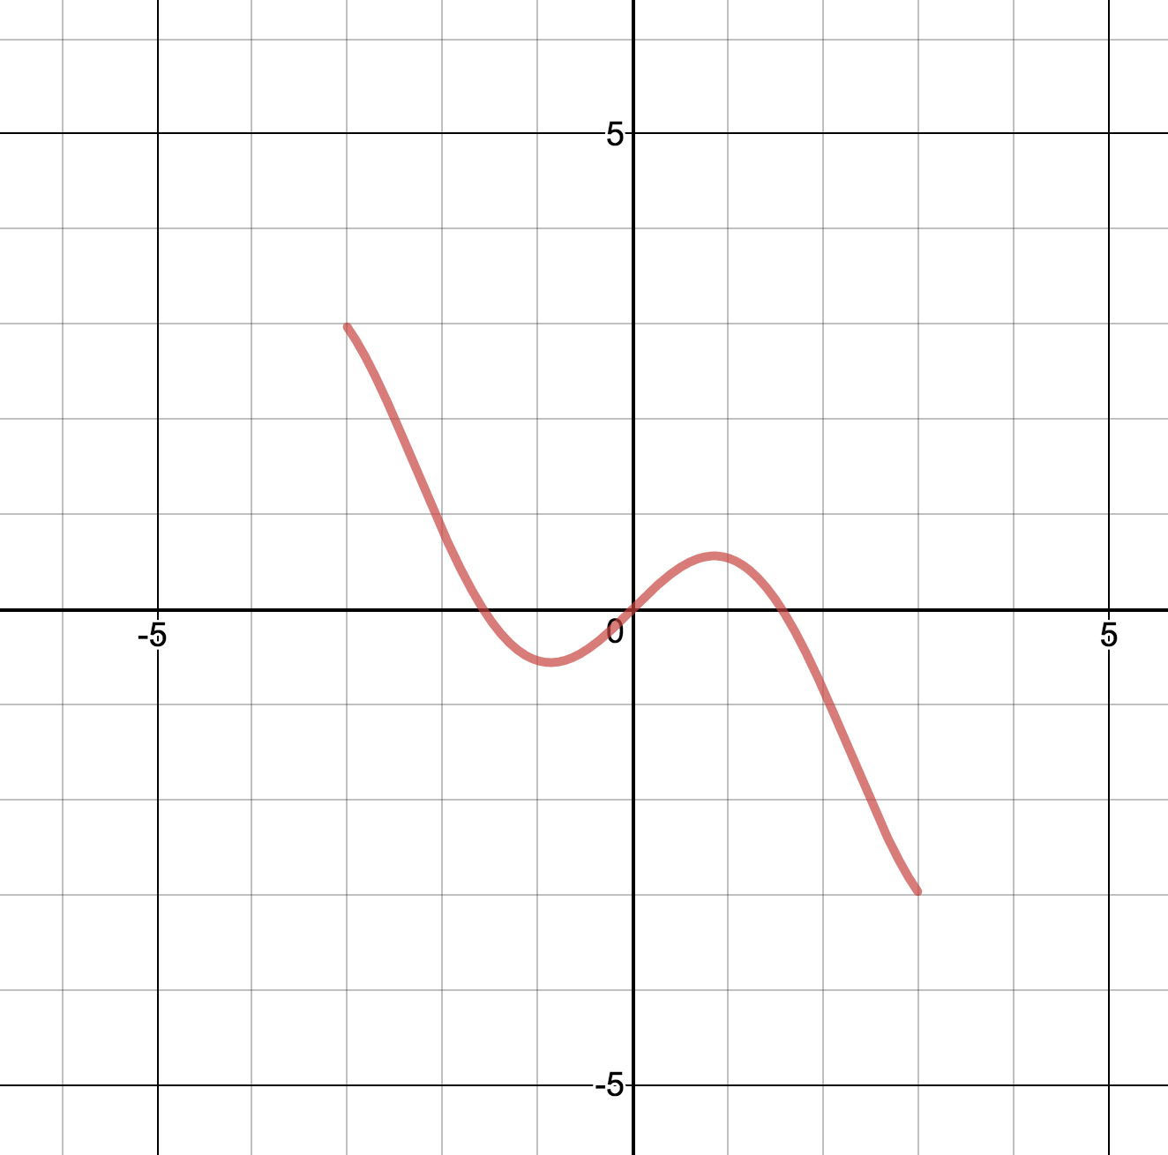

Find Range and Domain: ___________________________________

Is the function Even/Odd? __________________________________

Graph $f(x+2)$. Range and Domain: _________________________________

Graph $f\left(\frac{x}{2}\right)$. Range and Domain: _________________________________

