Name:__________________________ Date:_________

Class worksheet: Alg2H
Polynomials: Factors, roots, zeros
(book chapter 11)

Example polynomial:

$$P\left(x\right)= x^{5}-9x^{4}+31x^{3}-53x^{2}+48x-18$$

Degree of polynomial: ____ Leading Coefficient: ____

End behavior: ________________________

Factoring:

$$P\left(x\right)=\left(x-1\right)⋅(x^{4}-8x^{3}+23x^{2}-30x+18)$$

Factor Theorem:

Roots:

Fundamental theorem of Algebra.

Complex roots

Back to our polynomial:

$$P\left(x\right)= x^{5}-9x^{4}+31x^{3}-53x^{2}+48x-18$$

End behavior:

Factoring:
$$P\left(x\right)=\left(x-1\right)⋅{\left(x-3\right)}^{2}⋅(x^{2}-2x+2)$$

Roots:
1. ____________ 4. ___________
2. _____________ 5. ___________
3. _____________

y-intercept: __________________________

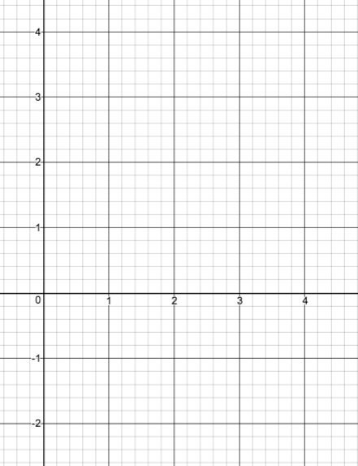
Plotting:

