Unit 12: Inverse functions
I. Given the function:
$$f\left(x\right)=2x+1$$

- Indicate in the table a few key values for (x,y).
- Plot the function on the axes below.
- Graph the line y=x as dotted line.
- Graph Method: Find the inverse function by reflecting the original with respect to the symmetry line.
- Table Method: Fill in the table below based on the table you filled for f(x).
- Mark these points on the graph. Did you get the same line?
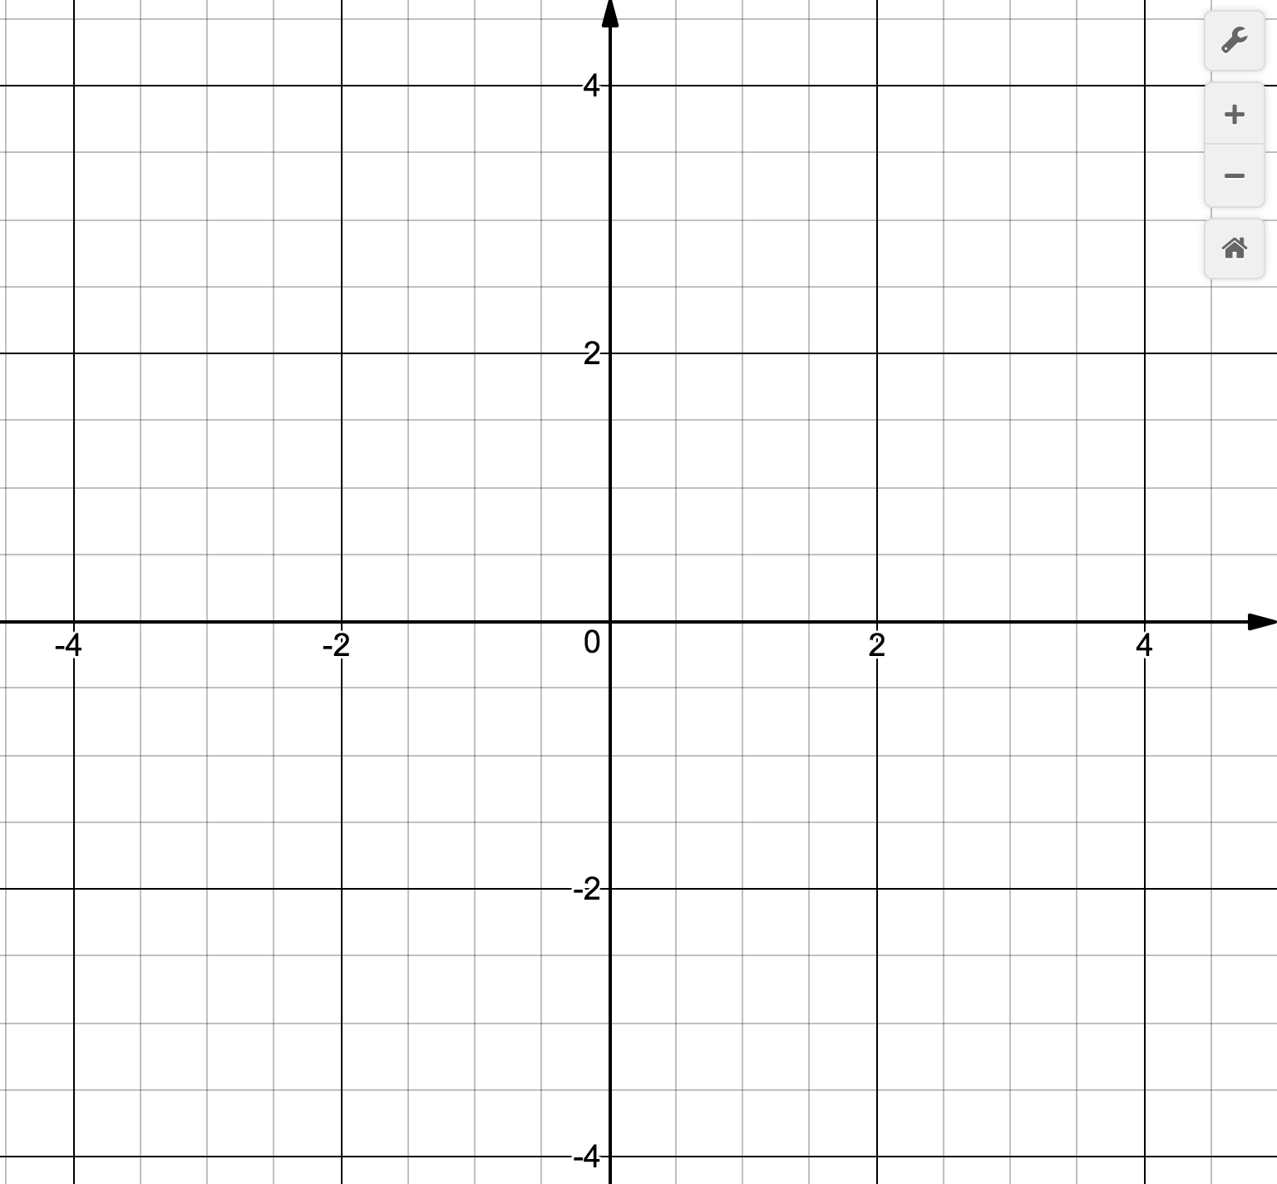
$$f^{-1}\left(x\right)$$

$$f\left(x\right)$$

$$x$$  (in) | $$y$$  (out)

(in)  $$x$$ | (out)  $$y$$

Algebraic method

$$f\left(x\right)=2x+1$$

- Using swapping x y method, find the formula for the inverse function.

II. Given the function:
$$f\left(x\right)=\sqrt{x+1}$$

- Indicate in the table a few key values for (x,y).
- Plot the function on the axes below.
- Graph the line y=x as dotted line.
- Graph Method: Find the inverse function by reflecting the original with respect to the symmetry line.
- Table Method: Fill in the table below based on the table you filled for f(x).
- Mark these points on the graph. Did you get the same line?

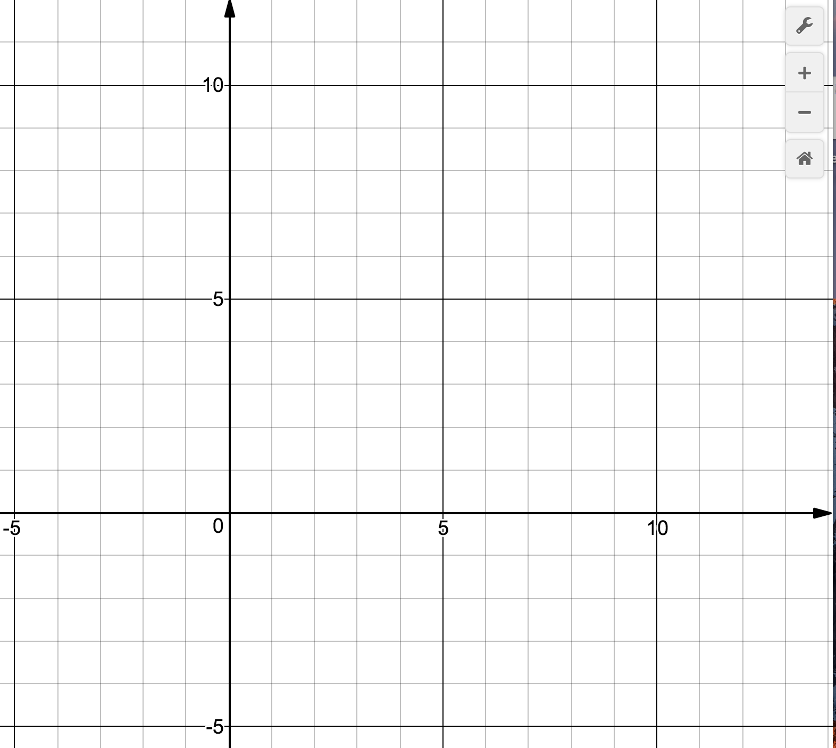
$$f^{-1}\left(x\right)$$

Domain:________

Range: _________

$$f\left(x\right)$$

Domain:________

Range: _________

$$x$$  (in) | $$y$$  (out)

(in)  $$x$$ | (out)  $$y$$

Algebraic method

$$f\left(x\right)=\sqrt{x+1}$$

- Using swapping x y method, find the formula for the inverse function.

