Exploration: Graphs of quadratic equations
No-Desmos

I. Create a table of values, and then graph the function
$f\left(x\right)=x^{2}-1$ for $-3≤x≤3$.

$$x$$ | $$f(x)$$
-3
-2
-1
0
1
2
3

- Where does the function intercept the y-axis?
  - Can you obtain this from the quadratic function equation?

- Where does the function intercept the x-axis?
  - Can you find these using algebraic process?

- What is the axis-of-symmetry?
  - Can you see it from the graph? Table?
  - Write the y-coordinate of the lowest point on the graph of f(x)

II. Create a table of values, and then graph the function
$f\left(x\right)=(x-4)(x+2)$ for $-3≤x≤5$
x | f(x)
-3
-2
-1
0
1
2
3
4
5

- For what x value(s) is f(x) equal to zero?
- What is the axis of symmetry?
- What is the minimum value of f(x)?

III. Create a table of values, and then graph the function
$g\left(x\right)=-x^{2}-2x+8$ for $-5≤x≤3$

x | g(x)
-5
-4
-3
-2
-1
0
1
2
3

- What is the y-intercept of the function?
- How and why is this graph different compared to the previous two?
IV. Create a table of values, and then graph the function
$m\left(x\right)=0.5{\left(x-3\right)}^{2}-2$ for $-1≤x≤7$
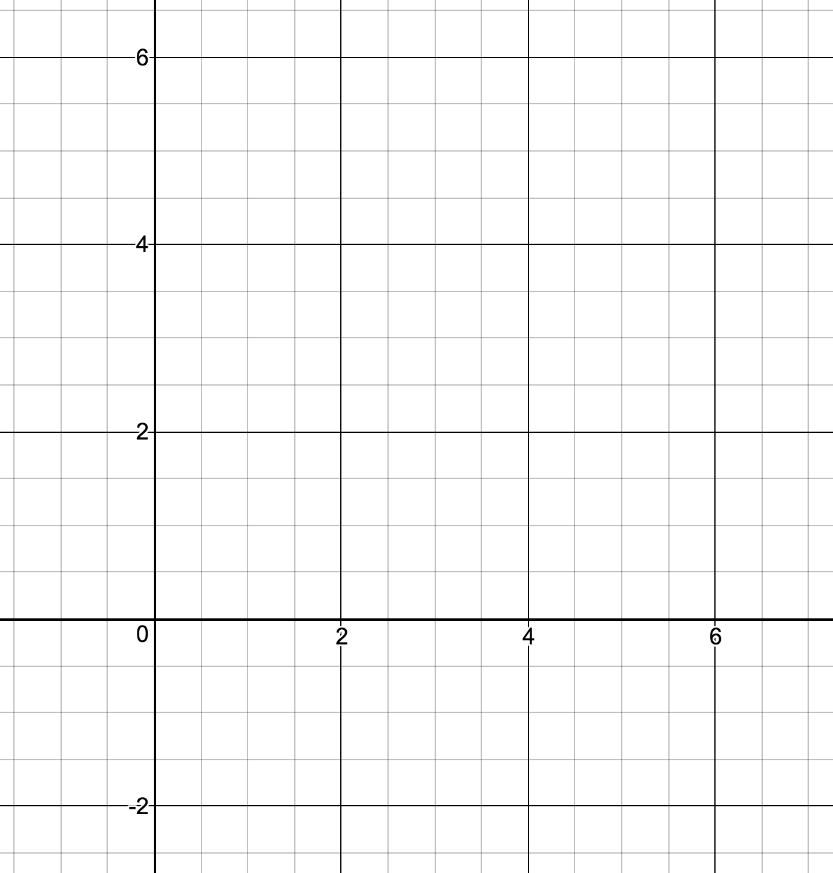
x | m(x)
-1
0
1
2
3
4
5
6
7

- What is the y-intercept of the function?

- What are the x-intercepts of the function?

V. Draw the function q(x) on the same axes. Use different colors.
$q\left(x\right)=2{\left(x-3\right)}^{2}-2$ for $1≤x≤5$

x | 1 | 2 | 3 | 4 | 5
q(x)

VI. Create a table of values, and then graph the function
$h\left(x\right)=-0.5{\left(x-3\right)}^{2}-2$ for $-1≤x≤8$
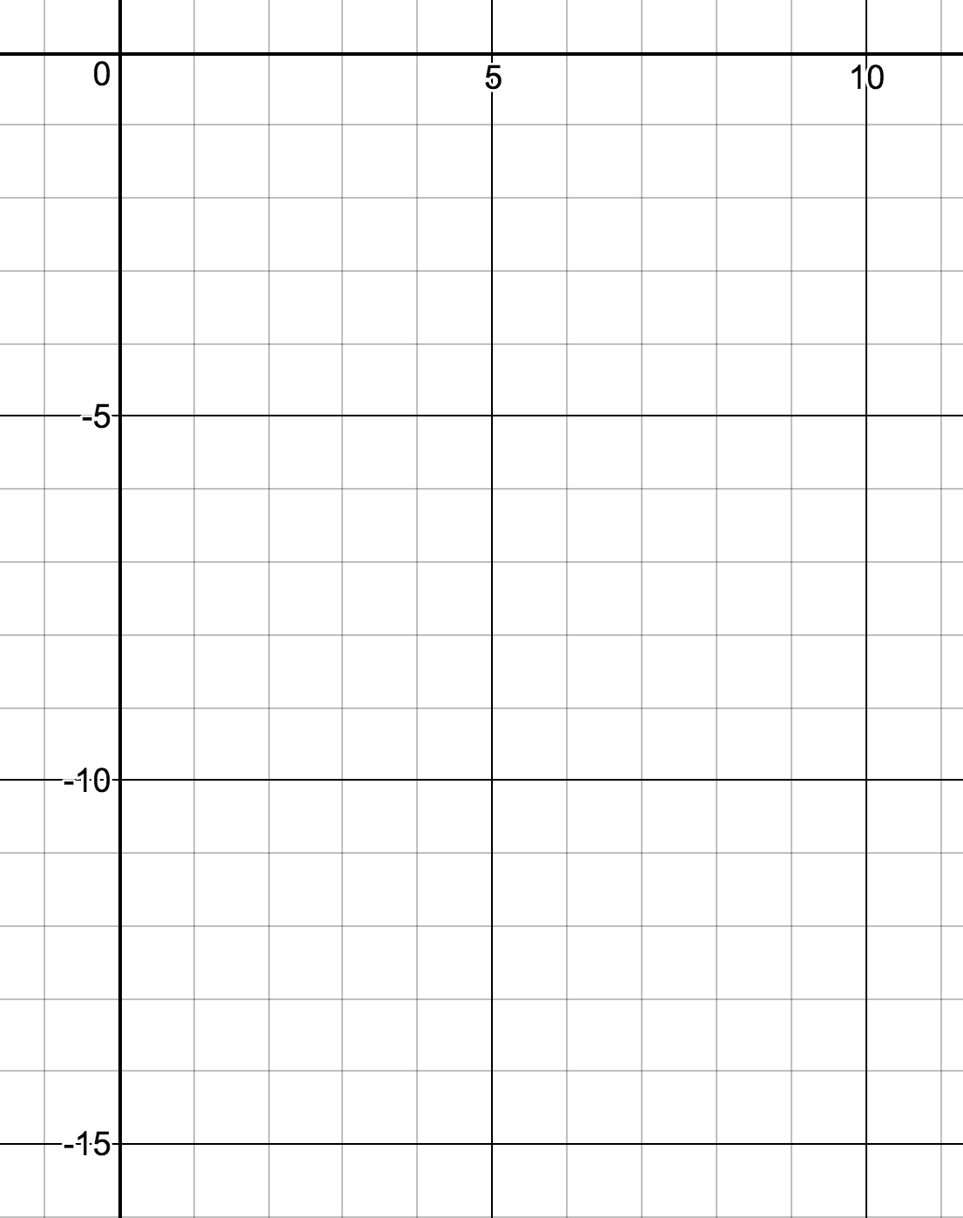
x | h(x)
-1
0
1
2
3
4
5
6
7
8

- What is the y-intercept of the function?

- What are the x-intercepts of the function?

VII. Look back at the last 3 examples. Any insights and observations?

=== End ===

