Name:__________________________ Date:_________

Class/Home worksheet: Alg2H
Vertex form
(book chapter 9, page 404 and onward)

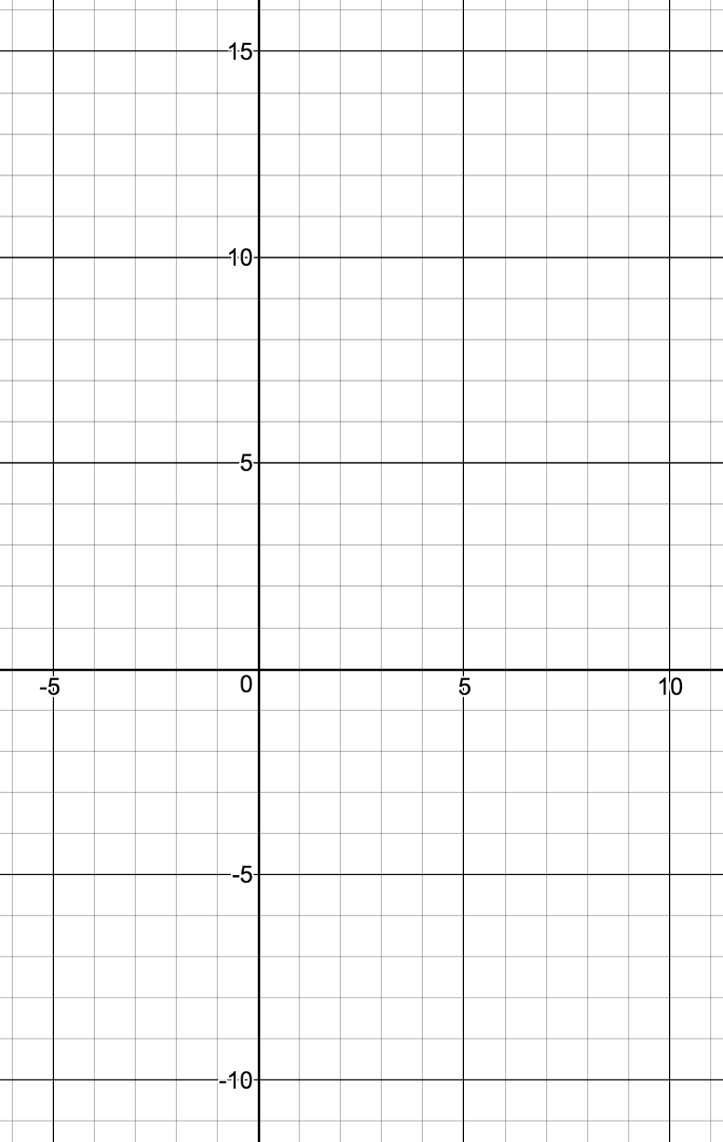
Writing quadratic expression as a function:
Standard form:

Useful for:

Factored form:

Useful for:

Vertex form:

Useful for:

Vertex form

The rule of h

The rule of k

The rule of a

Question:

Given the function

$$f\left(x\right)=(2x+2)(x-3)$$

- Write in standard form

- Solve $f\left(x\right)=0$ for x (using the quadratic equation)

- Write in Vertex form. What is the vertex?

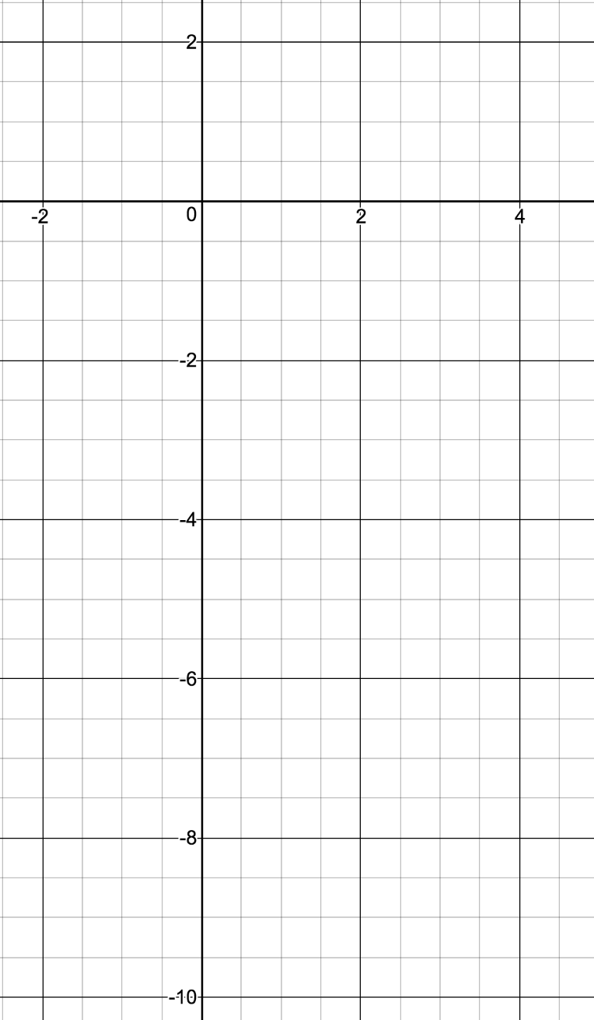

- What is the Y-intercept?

- What is the X-intercept?

- Write in factored form

- Plot the function.

General process of moving from one form to another

Standard form:

Factored form

Vertex form

Using the following function:

$f\left(x\right)= 2(x-1)(x+2)$

Standard form:

Vertex form:

Y-intercept:

X-intercept:

Vertex:
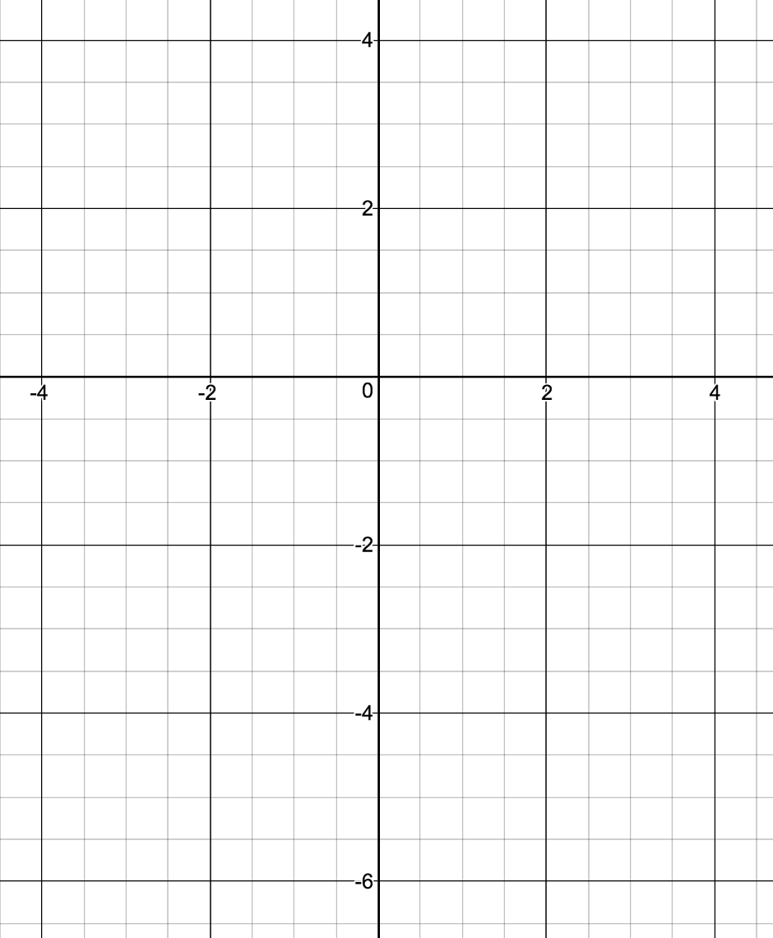

Plot (free hand), and compare:

