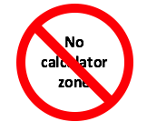
Insights project: Challenge Question

Heptadecagon (and friends)
Question:

Heptadecagon is a 17 sided polygon. In the heptadecagon below a secret number is hidden behind every vertex. On each side of the heptadecagon a number denotes the SUM of the two neighbouring secret numbers.
Find the numbers hidden behind the vertices denoted as A, B and C.
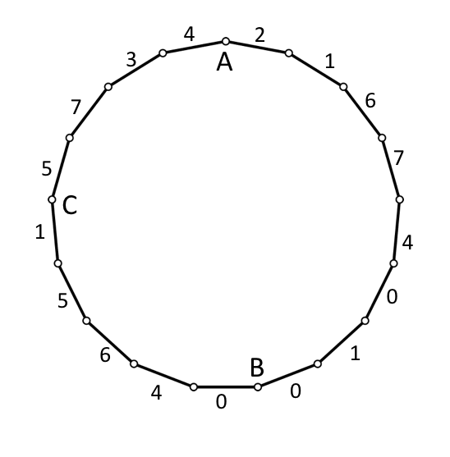
Extra Credit: Would the same method of solution work for Octadecagon (18 sided polygon)?

Some specific guides and rules:
- Show your work. You may use calculator to verify your results, but your work should show how you can do it without calculator.
- Hint 1 (Which you will need to submit!): Build your OWN created simpler problem. Construct a problem similar to the above using a Triangle. You can choose your own secret number, compute the sums, and then try and find the numbers!
- Hint 2: If Hint 1 didn’t help, construct the problem using a Pentagon.
- Hint 3: (For the extra credit portion) Construct a problem using a quadrilateral.

General rules for challenge questions:
- You are allowed to work with a group and collaborate with up to 3 people.
- If you work as a group (or collaborate), keep in mind:
  - Each member should submit her/his own work.
  - Each member needs to write the names of all group members on the work.
- You are allowed to have external (adult, tutor, etc.) help, but please don’t solicit for the full solution. The goal is for you yourself to try and solve it, and understand the subtleties of the problem. Again, please note that as well on the sheet. NO points will be taken off: I just want to have a real appreciation of how the class is doing on these.
- Have fun solving it!!

=== End ====

Solution

(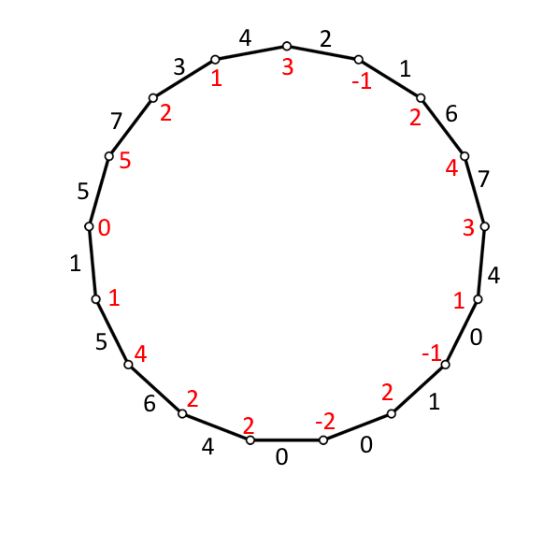

Related: Page 146, thinking mathematically.
No calculator zone

