Insights project: Inquiry model Student name:__________________________
Date:___________________ Block: _________

Project name : 2 Overlapping Circles^

Observations and doodles
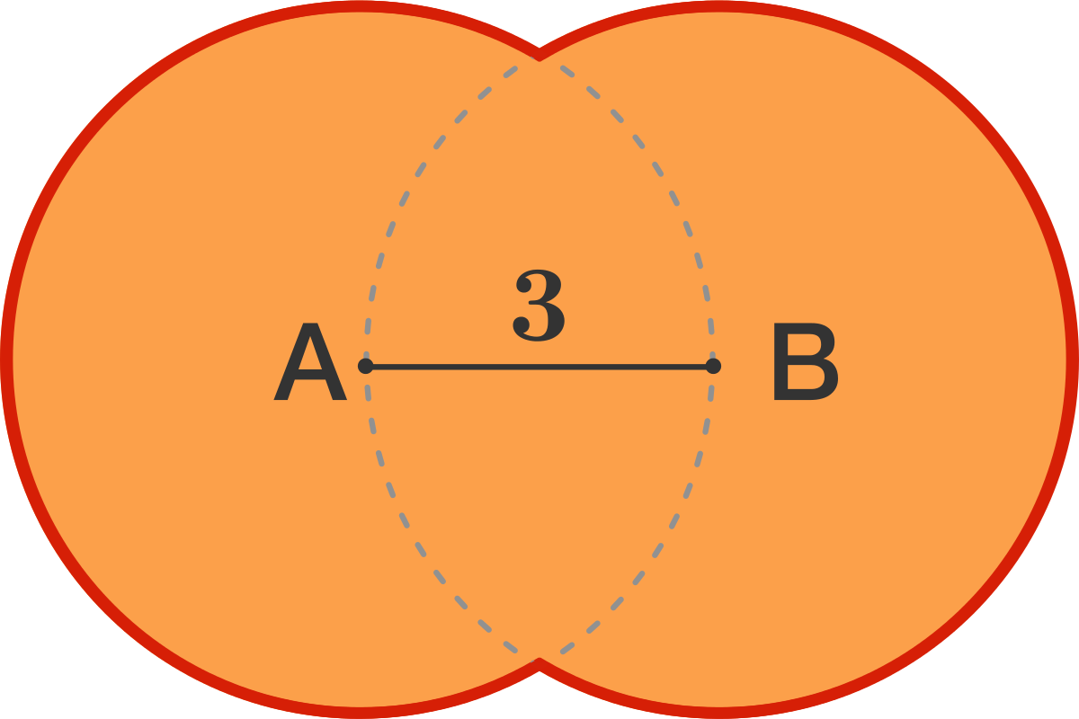

What is the length of the red perimeter of this figure?

- Two overlapping circles, with centers $A$ and $B$, form the figure above.
- Line segment $\overline{AB}$ is a radius of both circles.

Wrong answers and guesses (Goldilocks)

Solve + explain

