Insights project: Inquiry model Student name:__________________________
Date:___________________ Block: _________

Project name : Chain Patterns^

Observations and doodles
Squares

Pentagons

Hexagons

Heptagons

Octagons
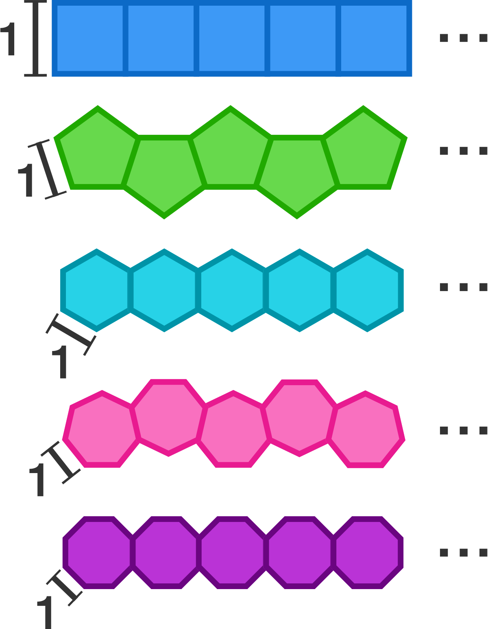

Some chains of regular figures, each with side lengths of 1, are shown above.
Which of the chains can't be extended to have a perimeter of exactly 50?

Solve + explain

