Insights project: Inquiry model Student name:__________________________
Date:___________________ Block: _________

Project name : Fan^

Observations and doodles
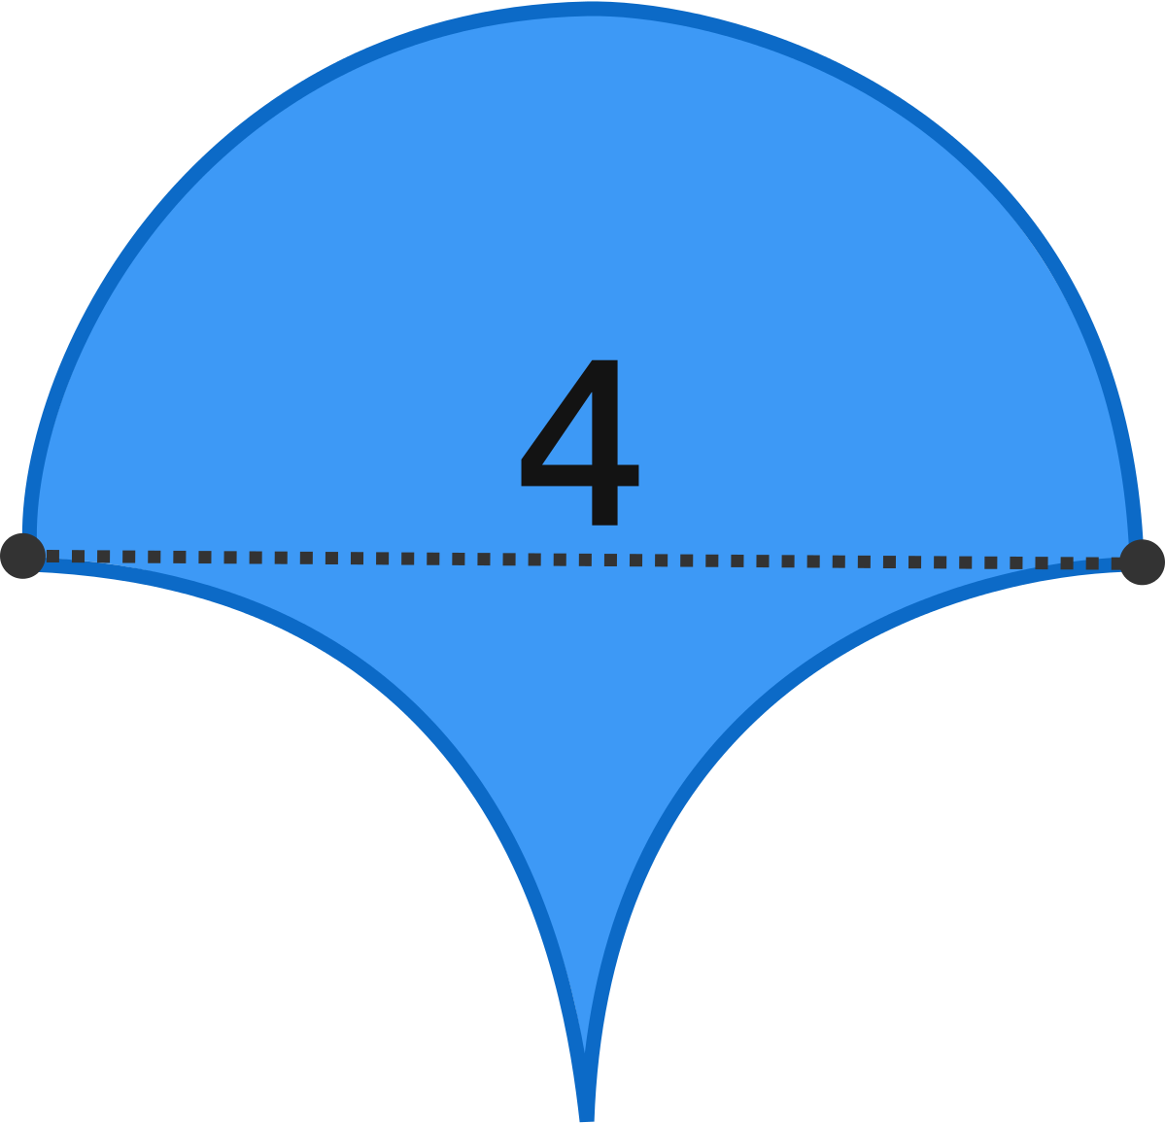

What is the area of the blue figure?

Wrong answers and guesses (Goldilocks)

Solve + explain

