Insights project: Inquiry model Student name:__________________________
Date:___________________ Block: _________

Project name : Odd Triples^

Observations and doodles
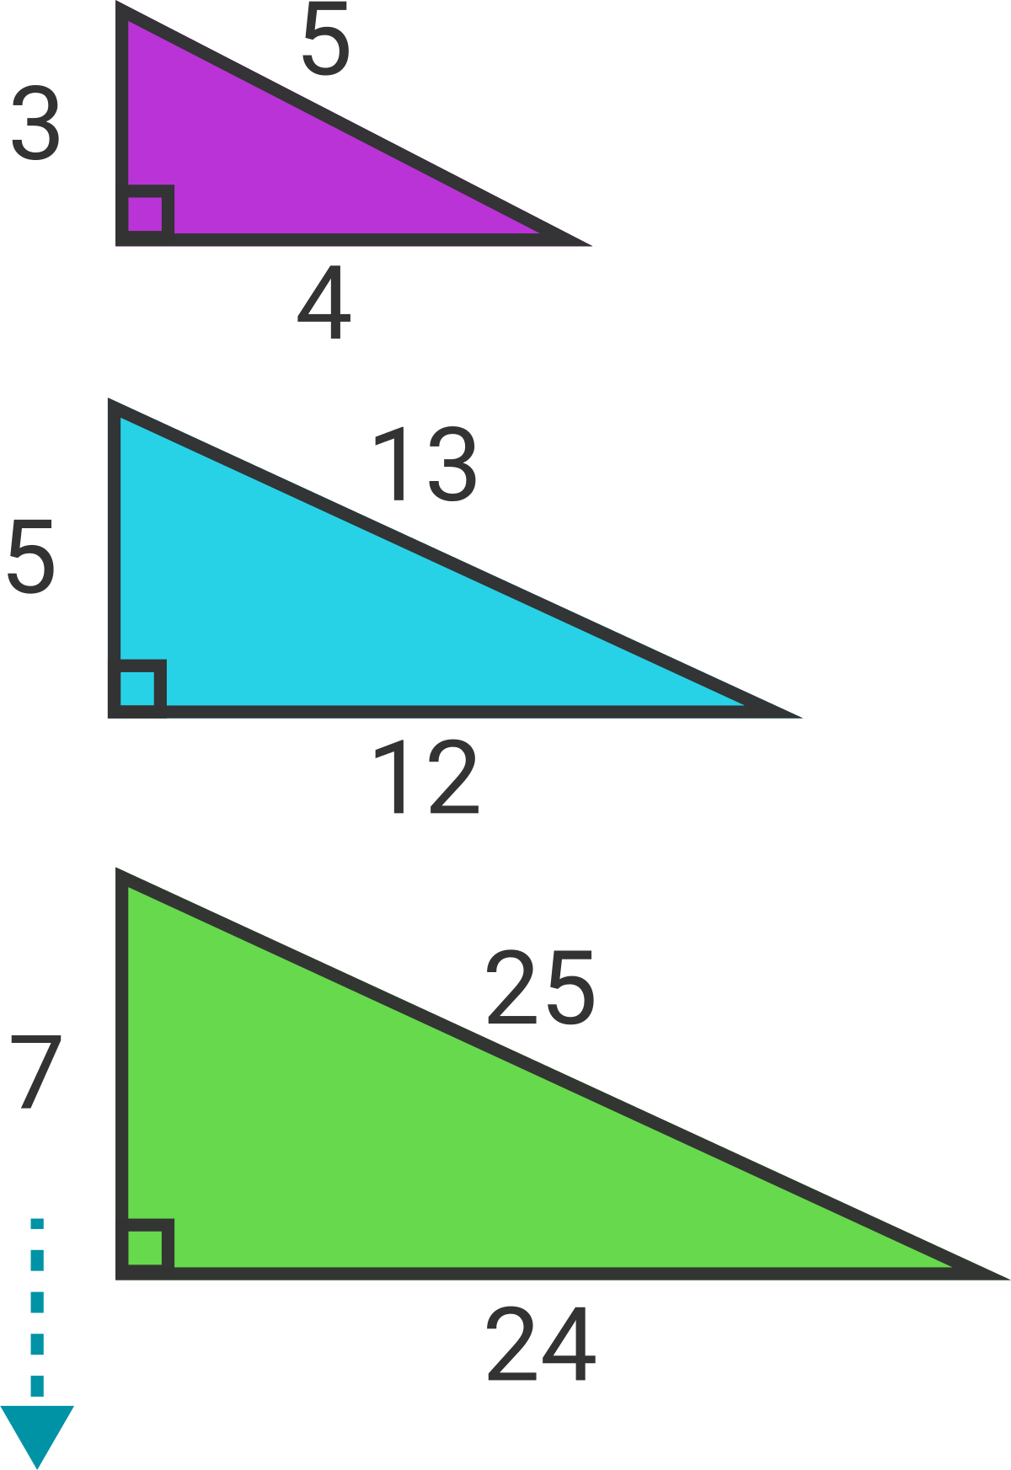

True or False:
Every odd number greater than 1 is the smallest member of a primitive Pythagorean triple.
Definitions:
- A "Pythagorean triple" is a set of three whole numbers which can be the three side lengths of a right triangle.
- "Primitive" means the three numbers don't have a common factor. For example, the Pythagorean triple (6,8,10) is not primitive because all three numbers are divisible by 2.
Wrong answers and guesses (Goldilocks)

Solve + explain

