Insights project: Inquiry model Student name:__________________________
Date:___________________ Block: _________

Project name : mini-Minesweeper^

Observations and doodles
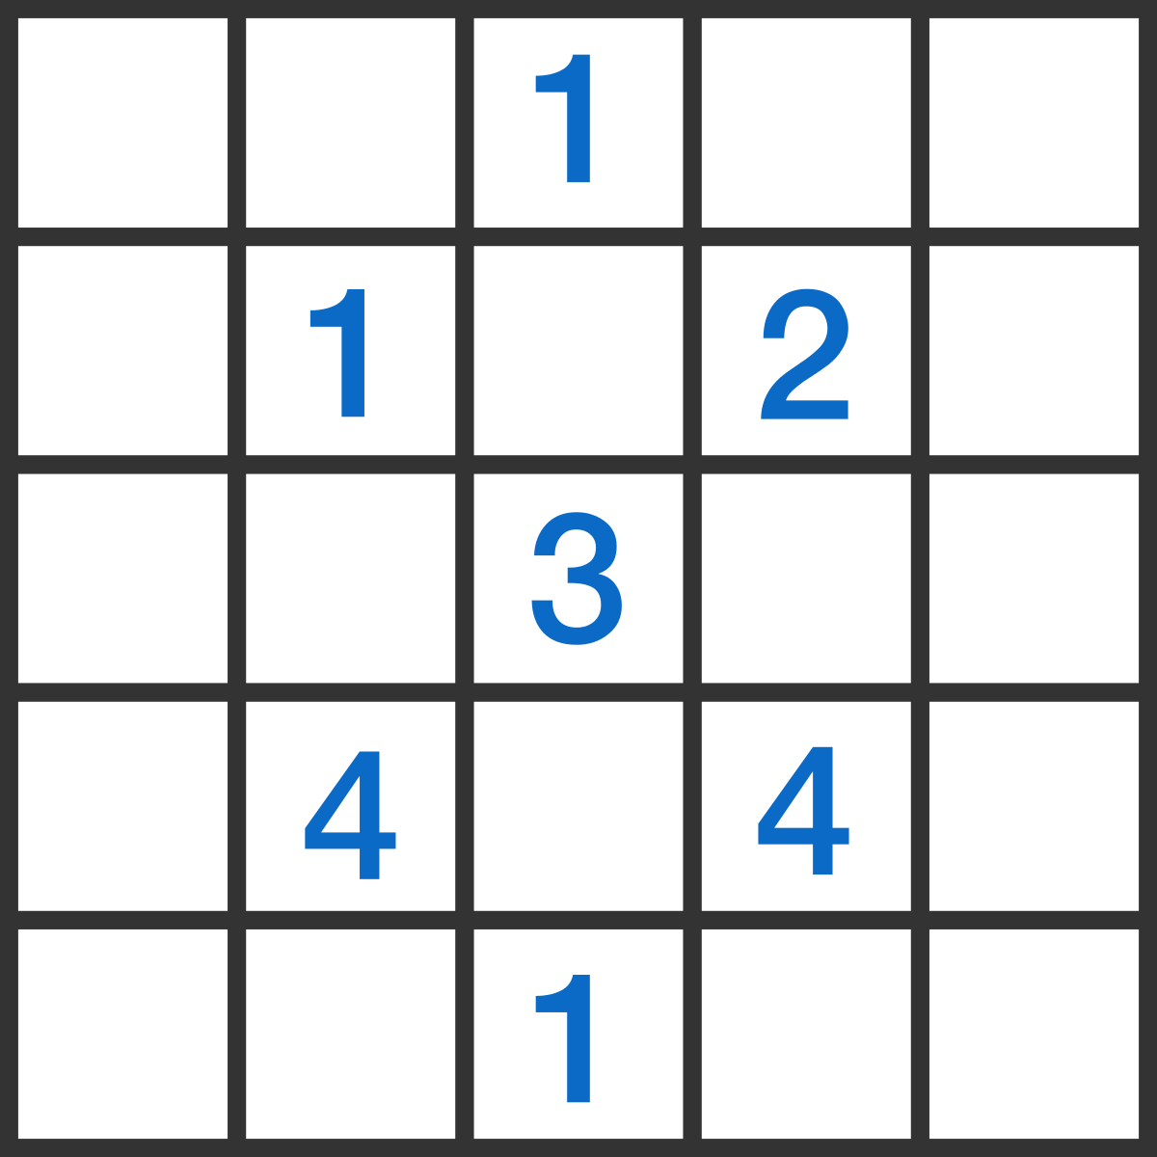

The grid shown has some squares that contain mines and some that are safe; every square with a number is safe. In addition, the numbers indicate how many of the adjacent squares (vertically, horizontally, or diagonally) have mines.
How many mines are there on the grid?
Wrong answers and guesses (Goldilocks)

Solve + explain

